Part- 4 Chapter- 18
Aplia Homework: International Trade and Comparative Advantage

1. The basis of trade
Suppose that Italy and Portugal both produce cheese and wine. Italy's opportunity cost of producing a bottle of wine is 2 pounds of cheese. That is, Italy forgoes the production of 2 pounds of cheese when it produces a bottle of wine. Portugal's opportunity cost of producing a bottle of wine is 4 pounds of cheese.
___________ a comparative advantage in the production of wine.

___________ a comparative advantage in the production of cheese.

2. Comparative and absolute advantage
Paolo and Sharon are farmers. Each one owns a 20-acre plot of land. The following table shows the amount of rye and corn each farmer can produce per year on a given acre. Each farmer chooses whether to devote all acres to producing rye or corn or to produce rye on some of the land and corn on the rest.
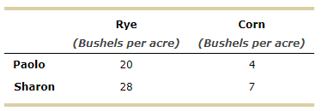
On the following graph, use the blue line (circle symbol) to plot Paolo's production possibilities frontier (PPF), and use the purple line (diamond symbol) to plot Sharon's PPF.

________ has an absolute advantage in the production of rye, and _________ has an absolute advantage in the production of corn.

Paolo's opportunity cost of producing 1 bushel of corn is _____ bushels of rye, whereas Sharon's opportunity cost of producing 1 bushel of corn is ____ bushels of rye. Because Paolo has a _________ opportunity cost of producing corn than Sharon, ________ has a comparative advantage in the production of corn, and ________ has a comparative advantage in the production of rye.

3. Specialization and trade
When a country specializes in the production of a good, this means that it can produce this good at a lower opportunity cost than its trading partner can. Because of this comparative advantage, both countries benefit when they specialize and trade with each other.
The following graphs show the production possibilities frontiers (PPFs) for Maldonia and Sylvania. Both countries produce lemons and sugar, with each initially (i.e., before specialization and trade) producing 24 million pounds of lemons and 12 million pounds of sugar, as indicated by the grey stars marked with the letter A.
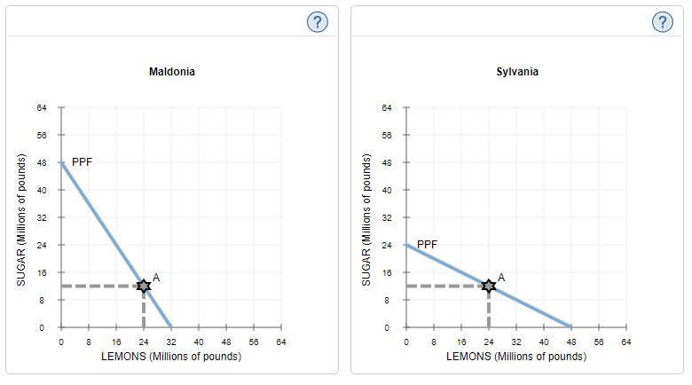
Maldonia has a comparative advantage in the production of _______, while Sylvania has a comparative advantage in the production of ________. Suppose that Maldonia and Sylvania specialize in the production of the goods in which each has a comparative advantage. After specialization, the two countries can produce a total of ______ million pounds of sugar and ______ million pounds of lemons.

Suppose that Maldonia and Sylvania agree to trade. Each country focuses its resources on producing only the good in which it has a comparative advantage. The countries decide to exchange 24 million pounds of lemons for 24 million pounds of sugar. This ratio of goods is known as the terms of trade between Maldonia and Sylvania.
The following graph shows the same PPF for Maldonia as before, as well as its initial consumption at point A. Place a black point (plus symbol) on the graph to indicate Maldonia's consumption after trade.
Note: Dashed drop lines will automatically extend to both axes.

The following graph shows the same PPF for Sylvania as before, as well as its initial consumption at point A.
As you did for Maldonia, place a black point (plus symbol) on the following graph to indicate Sylvania's consumption after trade.

True or False: Without engaging in international trade, Maldonia and Sylvania would not have been able to consume at the after-trade consumption bundles. (Hint: Base this question on the answers you previously entered on this page.)
True
False

4. Terms of trade
Suppose that Portugal and Switzerland both produce beer and stained glass. Portugal's opportunity cost of producing a pane of stained glass is 4 barrels of beer while Switzerland's opportunity cost of producing a pane of stained glass is 10 barrels of beer.
By comparing the opportunity cost of producing stained glass in the two countries, you can tell that _________ has a comparative advantage in the production of stained glass and ________ has a comparative advantage in the production of beer.

Suppose that Portugal and Switzerland consider trading stained glass and beer with each other. Portugal can gain from specialization and trade as long as it receives more than _________ of beer for each pane of stained glass it exports to Switzerland. Similarly, Switzerland can gain from trade as long as it receives more than _________ of stained glass for each barrel of beer it exports to Portugal.

Based on your answer to the last question, which of the following terms of trade (that is, price of stained glass in terms of beer) would allow both Switzerland and Portugal to gain from trade? Check all that apply.

2 barrels of beer per pane of stained glass
9 barrels of beer per pane of stained glass
16 barrels of beer per pane of stained glass
7 barrels of beer per pane of stained glass

5. The arguments for restricting trade
Suppose there is a policy debate over whether the United States should impose trade restrictions on imported ball bearings:
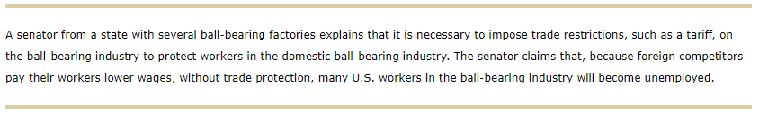
Which of the following justifications is the senator using to argue for the trade restriction on ball bearings?

Infant-industry argument
Strategic argument
Saving-domestic-jobs argument
National-defense argument
Unfair-competition argument

6. Lobbying for or against trade restrictions
Trade restrictions affect the overall welfare of an economy, since they alter the prices consumers pay and the quantities of goods produced and consumed domestically.
Trade restrictions, such as quotas, usually benefit domestic _________ and hurt domestic _________, since they __________ the domestic price of a good.

True or False: Consumers find it difficult to exert the political influence needed to remove trade restrictions, because the costs to consumers are very small and widely dispersed, which makes it difficult for consumers to organize.
True
False

7. Import demand and export supply
The following graph shows the domestic demand for and domestic supply of oil in the United States. Throughout the question, assume that the amount demanded by any one country does not affect the world price of oil.
Use the graph to help you answer the following questions. You will not be graded on any changes you make to this graph.
Note: Once you enter a value in a white field, the graph and any corresponding amounts in each grey field will change accordingly.
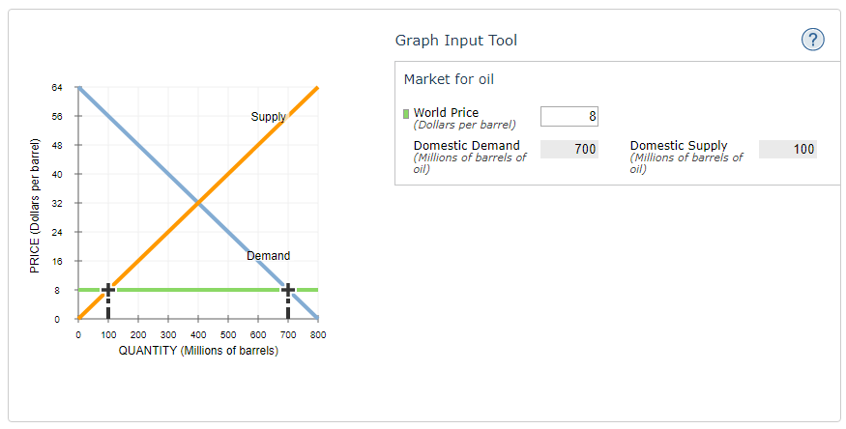
When the world price of oil is $40 per barrel of oil, the United States _______ _______ million barrels of oil.

When the world price of oil is $24 per barrel of oil, the United States ________ ______ million barrels of oil.

8. Effects of a quota on domestic prices
The following graph shows the domestic demand for and supply of barley in Canada. The horizontal green line shows the world price of $2 for a bushel of barley. Canada imports barley primarily from the United States. Assume that the amount demanded by any one country does not affect the world price of barley.
Use the graph to help you answer the following questions. You will not be graded on any changes you make to this graph.
(Note: Once you enter a value in a white field, the graph and any corresponding amounts in the grey fields will change accordingly.)
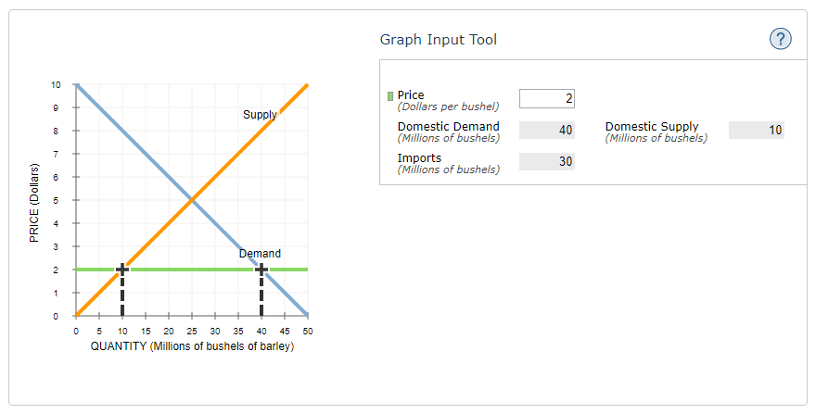

The Canadian government decides to impose trade restrictions on barley imports by setting a quota of 10 million bushels of barley. With the quota, the price of barley in Canada will be ______ per bushel.

The Canadian government explains that it is necessary to impose trade restrictions on barley to protect workers in the domestic barley industry. Assume that the Canadian government would like to generate government revenue through its protectionist policies.
Which of the following would provide the Canadian government with revenue? Check all that apply.

A quota on barley in which the import licenses are distributed via lottery
A quota on barley in which import licenses are given to the U.S. government for free distribution to U.S. barley producers
A tariff on U.S. barley
A quota on barley in which import licenses are auctioned off to U.S. barley producers

9. Effects of a tariff on international trade
The following graph shows the domestic supply of and demand for oranges in Guatemala. The world price (PW) of oranges is $820 per ton and is represented by the horizontal black line. Throughout the question, assume that the amount demanded by any one country does not affect the world price of oranges and that there are no transportation or transaction costs associated with international trade in oranges. Also, assume that domestic suppliers will satisfy domestic demand as much as possible before any exporting or importing takes place.
Use the graph input tool to help you answer the following questions. You will not be graded on any changes you make to this graph.
Note: Once you enter a value in a white field, the graph and any corresponding amounts in each grey field will change accordingly.
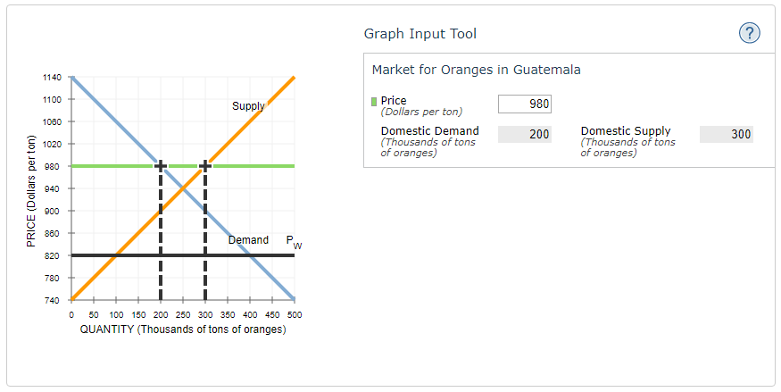

If Guatemala is open to international trade in oranges without any restrictions, it will import ________ tons of oranges.

Suppose the Guatemalan government wants to reduce imports to exactly 100,000 tons of oranges to help domestic producers.
A tariff of _______ per ton will achieve this.

A tariff set at this level would raise _________ in revenue for the Guatemalan government.

